Methodology

In the given project the development team will make use of the modified Waterfall approach. It consists of 5 stages, which follow strict, linear order, where each stage has to be fully completed before moving on to the next one (Winston Royce, 1970). In order for the Waterfall model to work, the requirements have to be well-defined, otherwise it is fairly easy to fail within this approach (Rumor, 2019). Since there is no possibility to navigate between the given stages, and fix the occurred problems on the way, the team has decided to use a modified version of the Waterfall method. It is being done in order to work around the previously mentioned issue by enabling the users of the model to go back and forth between the stages and fix the errors occurred during their work.

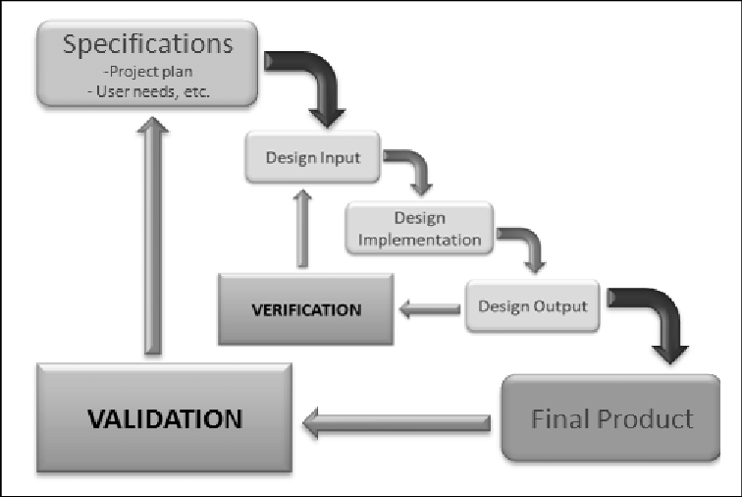

*Fig. 1. Waterfall method design process* ()